**MODULE : 2(CSS and CSS)**

1. **What are the benefits of Using CSS ?**

**Ans:-** CSS is Stands for cascading style sheet.

In css we use less code to increase faster page speed More code means slower page speed but less code means faster page speed .

If we need changes our format of a specific set of pages than its very easy to do with CSS , this type more benefits of using CSS.

1. **What are the disadvantages of CSS?**

**Ans**:- When we learn CSSin our mind many types of confusion like CSS levels .  
we confused in CSS levels like CSS such as CSS2,CSS3 …..

Also we see different type of browser work differently so we have to check the changes to implement in the website via CSS codes.

One of the main disadvantage of CSS is that it has Limited Security.

1. **What is the difference Between CSS2 and CSS3?**

**Ans:-** CSS2 was released in 1998 with added styles for other media types so that it can be used for page layout designing.

CSS2 designers could only use web safe fonts for being sure to use fonts that would always display same on every machine.

CSS2 which was comprised of single document.

CSS3 was released in 1999 and presentation style properties were added in it that allows you to build a presentation from document.

CSS3 designers can now use special font like those available in google fonts and typcast.

CSS3 has its specification divided into many individual modules which makes CSS3 a whole lot easier to handle.

CSS3 is the latest version of CSS, it is capable of supporting responsive designs and can also handle media queries as compared to CSS.

1. **Name a few CSS style Componenets.**

**Ans:**- The Components of CSS style Are:-

**Selector** :- Class name, Id name, Element Name.

**Value of property** :- Value that will be assigned

To attribute.

**Attribute** :- Name of the attribute you want to style for example border, color, color background, position etc..

**5**.**What do you understand by CSS opacity?**

**Ans:-** The opacity CSS property sets the opacity of an element ,opacity is the degree to which content behind an element is hidden and is the opposite of the transparency.

**Example:**- 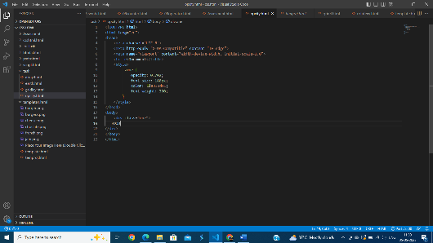

**6.How can the background color of element be changed?**

**Ans:-** we use css background color property to change a background color of element.

**Example:-**

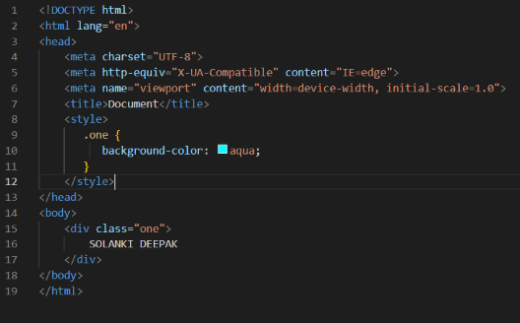

**7.How can image repetation of the backup be controlled?**

**Ans :-** Image repetation of the backup be controlled by this property ,

[ Background repeat property ] we can use no repeat values for the background repeat if you do not want to repeat an image.

**Example:-**  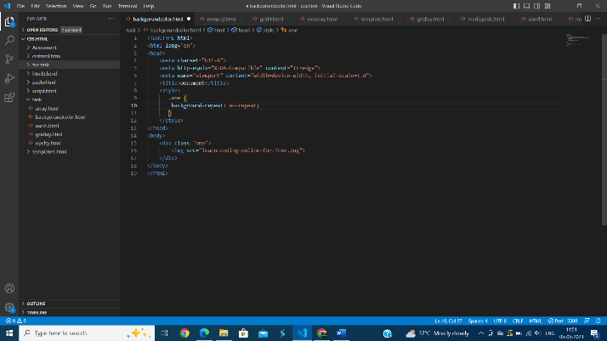

**8. What is the use of the background-position property?**

**Ans :-** The background-position property sets the starting position of background image.

**Example :-** 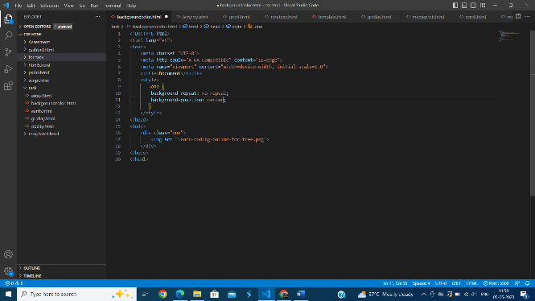

**9.Which property control the image scroll in the background?**

**Ans:-** The background Attachment property is control the image scroll in the background.

**Example:-** 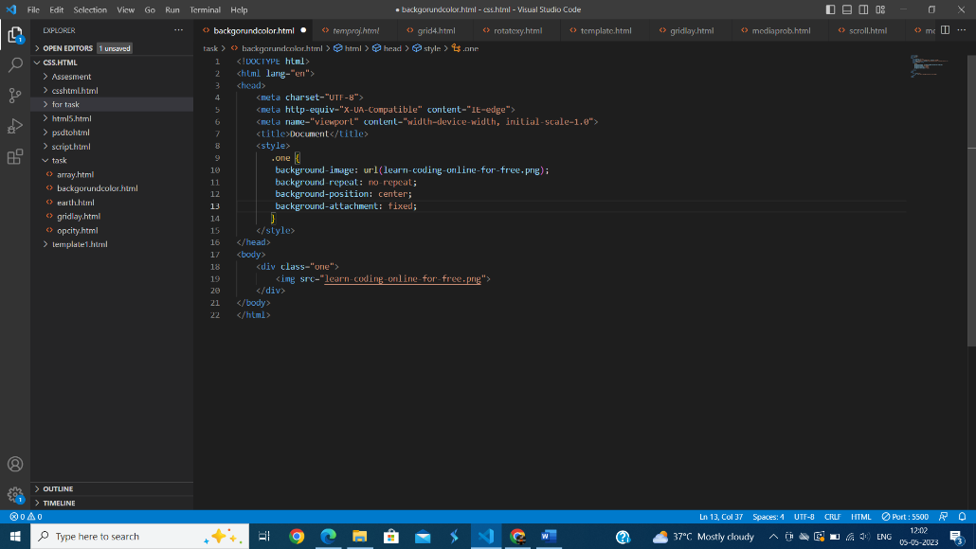

**10. How to center block element using CSS1?**

**Ans :-** InCSS1 we use <center> tag to all the elements will be centrally aligned.

**Example :-** 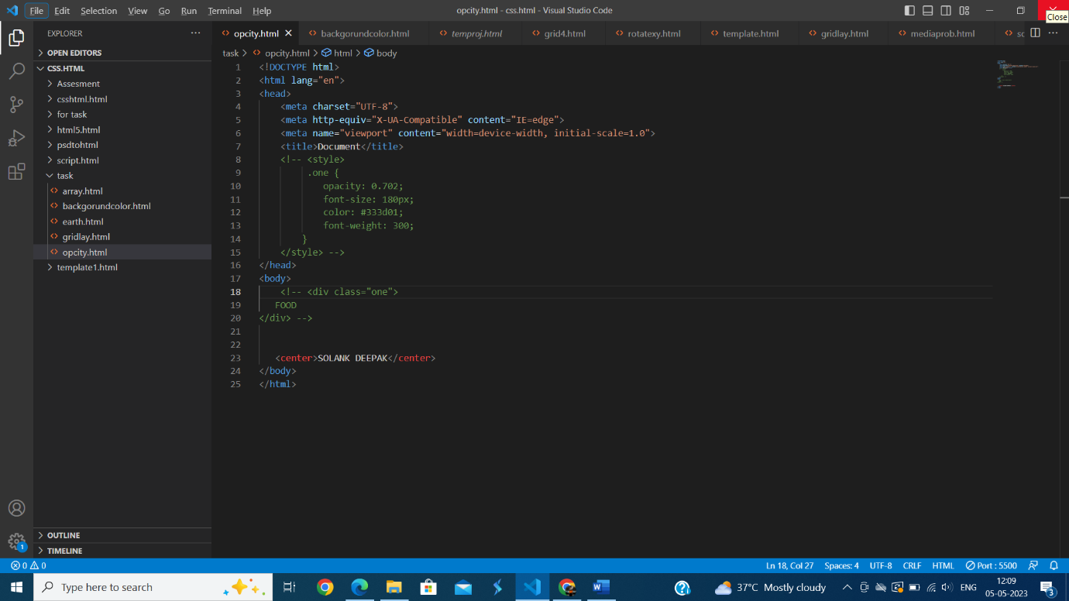

**11.What are the ways to integrate CSS as a webpage?**

**Ans :** 3 ways to integrate CSS as a Webpage.

Inline, Internal, External.

**12. Why should background and color be used as separate properties ?**

**Ans :-** Two Reason behind the background and color be used as separate properties .

The background property is a complex property in CSS, and if it is combined with color, the complexity will further increase. Color is an inherited property while the background is not.

**13.What is Embeded style sheets ?**

**Ans :-** An embedded style sheet is declared within the <head> element of an XHTML document.

It applies to the whole document, rather than just one element.

**14.What are the External Style Sheets ?**

**Ans :-** External Style Sheet is a separate file linked to an HTML Web page.

It comes with a CSS filename extension.

Style need to be used on a website can be declared in the external style sheet.

External style sheets ara an important tool from the webmasters perspective.

**15. What are the advantages and disadvantages of using external style sheets?**

**Ans :-** Advantage of External style sheet  the styles of numerous documents can be organized from one single file.

In complex contexts, Methods like selector and grouping can be implemented to apply styles

Disadvantage of External style sheet An extra download is essential to import style information for each file.

The execution of the file may be deferred till the external style sheet is loaded.

**16.What is the meaning of CSS?**

**Ans :-** CSS selectors are used to target the HTML elements on our web pages that we want to style.

There are a wide variety of CSS selectors available, allowing for fine-grained precision when selecting elements to style.

A CSS selector is the first part of a CSS Rule.

It is a pattern of elements and other terms that tell the browser which HTML elements should be selected to have the CSS property values inside the rule applied to them.

**17. What are the media types allowed by CSS?**

**Ans:-** 320px — 480px for Mobile devices.

481px — 768px for iPads, Tablets.

769px — 1024px for Small screens, laptops.

1025px — 1200px for Desktops, large screens.

1201px and more —Extra large screens, TV.

**18.What is the Rule set?**

**Ans :-**  A table of instructions used by a controlled interface to determine what data is allowable and how the data is handled between interconnected systems.

 A collection of rules or signatures that network traffic or system activity is compared against to determine an action to take—such as forwarding or rejecting a packet, creating an alert, or allowing a system event.